Exercise 1

Query

SELECT Title FROM movies;

SELECT director From movies;

SELECT Title, director From movies;

SELECT Title, year FROM movies;

SELECT * FROM movies;

Exercise 2

SELECT * FROM movies where id=6;

SELECT Title FROM movies where year BETWEEN 2000 AND 2010;

SELECT Title FROM movies where year NOT BETWEEN 2000 AND 2010;

SELECT * FROM movies where id IN(1,2,3,4,5)

Exercise 3

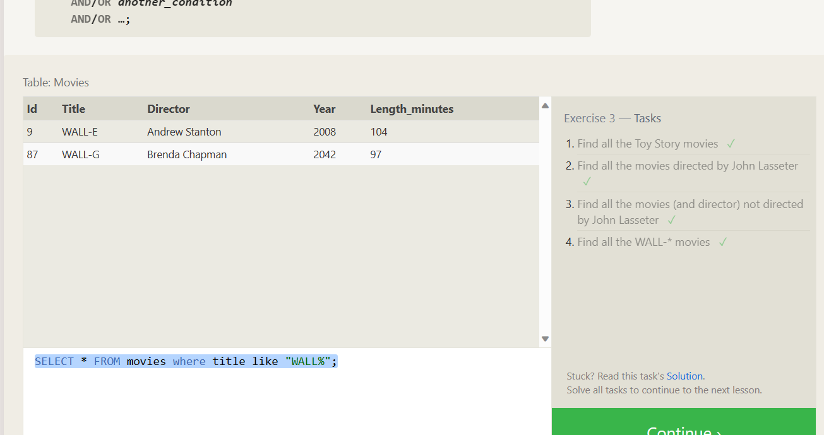

SELECT * FROM movies where title like "Toy%";

SELECT * FROM movies where director="John Lasseter";

SELECT title, director FROM movies where director!="John Lasseter";

SELECT * FROM movies where title like "WALL%";

Exercise 4

SELECT DISTINCT director FROM movies order by director ASC;

SELECT year, title FROM movies order by year desc limit 4;

SELECT year, title FROM movies order by title ASC limit 5;

SELECT year, title FROM movies order by title ASC limit 5 offset 5;

Exercise 5

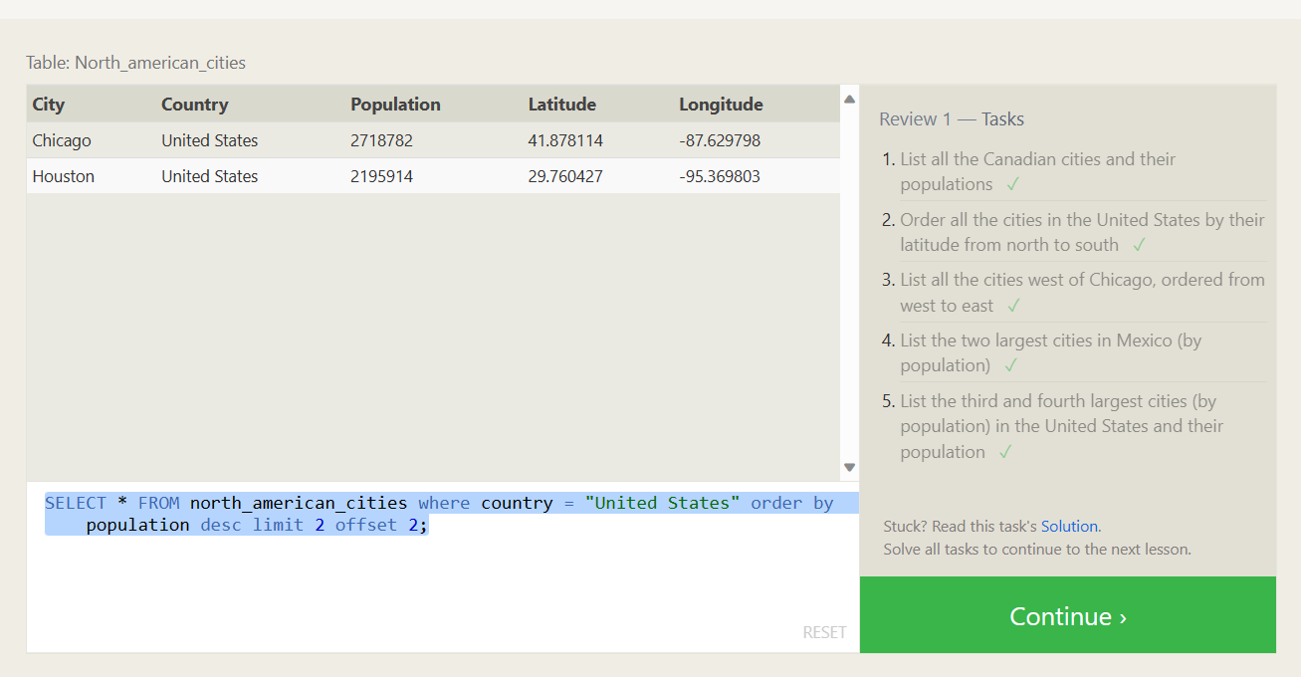

SELECT city,country, population FROM north_american_cities where country like "canada";

SELECT * FROM north_american_cities where country = "United States" order by latitude DESC;

SELECT * FROM north_american_cities where longitude <-87.629798 order by longitude asc;

SELECT * FROM north_american_cities where country = "Mexico" order by population desc limit 2;

SELECT * FROM north_american_cities where country = "United States" order by population desc limit 2 offset 2;

Exercise 6

SELECT title, domestic_sales, international_sales

FROM movies

JOIN boxoffice

ON movies.id = boxoffice.movie_id;

SELECT title, domestic_sales, international_sales

FROM movies

JOIN boxoffice

ON movies.id = boxoffice.movie_id

WHERE international_sales > domestic_sales;

SELECT title, rating

FROM movies

JOIN boxoffice

ON movies.id = boxoffice.movie_id

ORDER BY rating DESC;

Exercise 7

SELECT DISTINCT building FROM employees;

SELECT * FROM buildings;

SELECT DISTINCT building_name, role

FROM buildings

LEFT JOIN employees

ON building_name = building;

Exercise 8

SELECT name, role FROM employees

WHERE building IS NULL;

SELECT DISTINCT building_name

FROM buildings

LEFT JOIN employees

ON building_name = building

WHERE role IS NULL;

Exercise 9

SELECT title, (domestic_sales + international_sales) / 1000000 AS gross_sales_millions

FROM movies

JOIN boxoffice

ON movies.id = boxoffice.movie_id;

SELECT title, rating * 10 AS rating_percent

FROM movies

JOIN boxoffice

ON movies.id = boxoffice.movie_id;

SELECT title, year

FROM movies

WHERE year % 2 = 0;

Exercise 10

SELECT MAX(years_employed) as Max_years_employed

FROM employees;

SELECT role, AVG(years_employed) as Average_years_employed

FROM employees

GROUP BY role;

SELECT building, SUM(years_employed) as Total_years_employed

FROM employees

GROUP BY building;

Exercise 11

SELECT role, COUNT(*) as Number_of_artists

FROM employees

WHERE role = "Artist";

SELECT role, COUNT(*)

FROM employees

GROUP BY role;

SELECT role, SUM(years_employed)

FROM employees

GROUP BY role

HAVING role = "Engineer";

Exercise 12

SELECT director, COUNT(id) as Num_movies_directed

FROM movies

GROUP BY director;

SELECT director, SUM(domestic_sales + international_sales) as Cumulative_sales_from_all_movies

FROM movies

INNER JOIN boxoffice

ON movies.id = boxoffice.movie_id

GROUP BY director;

Exercise 13

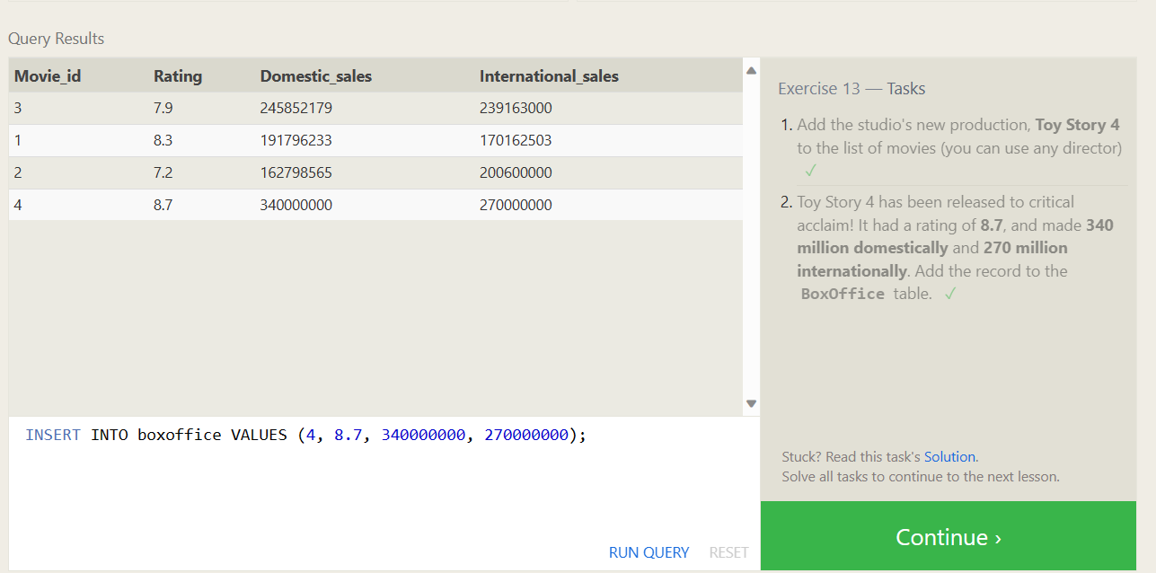

INSERT INTO movies VALUES (4, "Toy Story 4", "El Directore", 2015, 90);

INSERT INTO boxoffice VALUES (4, 8.7, 340000000, 270000000);

Exercise 14

UPDATE movies

SET director = "John Lasseter"

WHERE id = 2;

UPDATE movies

SET year = 1999

WHERE id = 3;

UPDATE movies

SET title = "Toy Story 3", director = "Lee Unkrich"

WHERE id = 11;

Exercise 15

DELETE FROM movies

where year < 2005;

DELETE FROM movies

where director = "Andrew Stanton";

Exercise 16

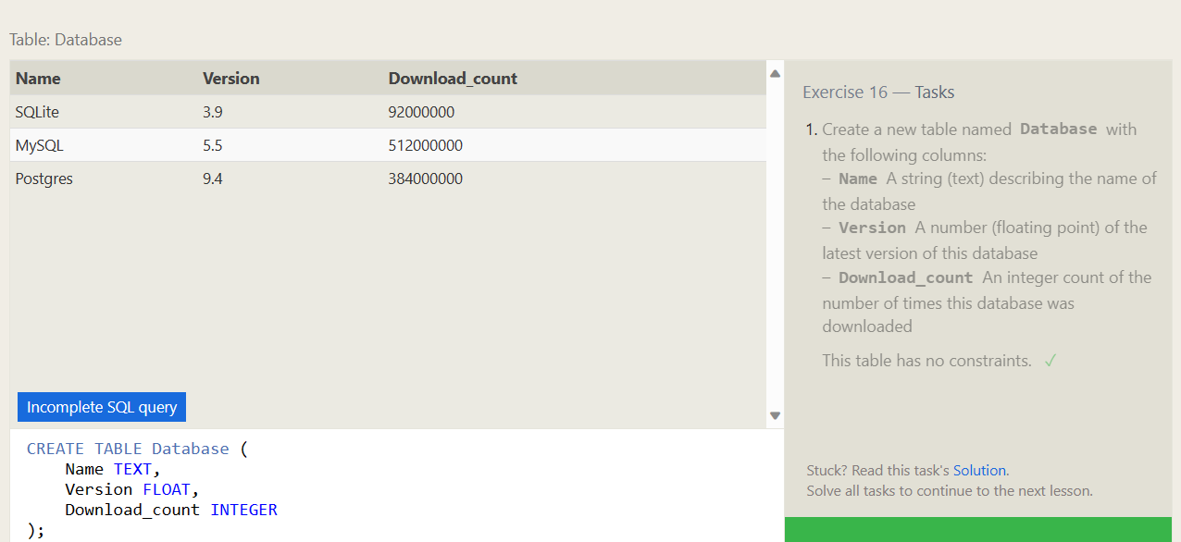

CREATE TABLE Database (

Name TEXT,

Version FLOAT,

Download_count INTEGER

);

Exercise 17

ALTER TABLE Movies

ADD COLUMN Aspect_ratio FLOAT DEFAULT 2.39;

ALTER TABLE Movies

ADD COLUMN Language TEXT DEFAULT "English";

Exercise 18

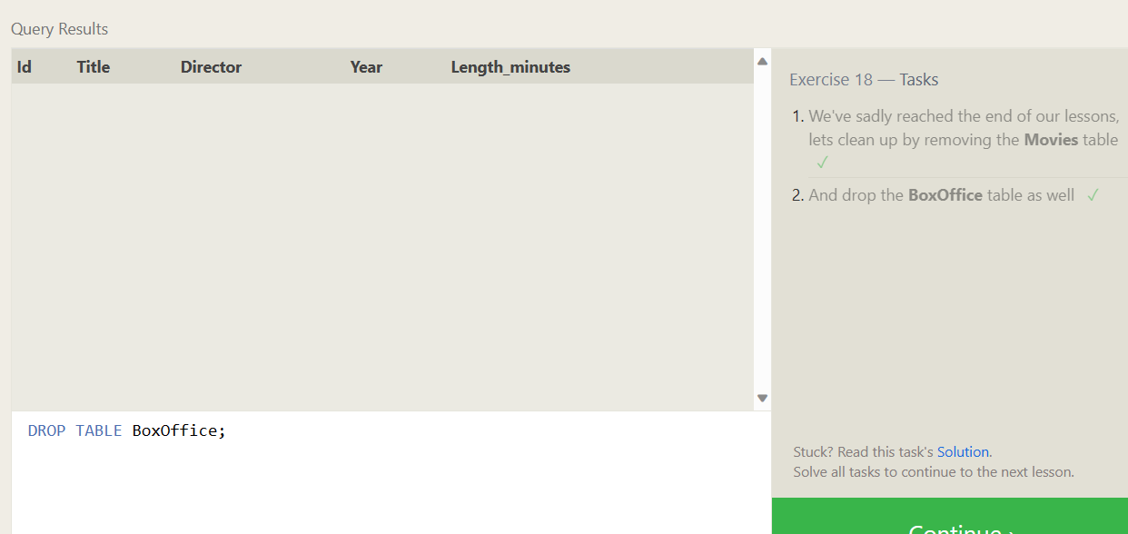

DROP TABLE Movies;

DROP TABLE BoxOffice;

Certification

